ORACLE:

<https://www.techonthenet.com/oracle/datatypes.php>

https://www.educba.com/oracle-data-types/?source=leftnav

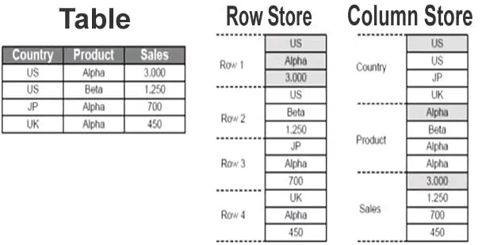

Table is called object in oracle

Create table

1. **CREATE** **TABLE** customers
2. ( customer_id number(10) NOT NULL,
3. customer_name varchar2(50) NOT NULL,
4. city varchar2(50)
5. );

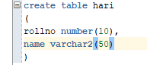

Create Table as

Copy table from other with row and columns all values also copied

CREATE TABLE newcustomers

AS (SELECT * FROM customers );



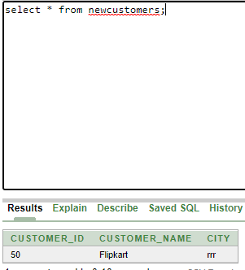

ALTER TABLE:

ALTER TABLE statement specifies how to add, modify, drop or delete columns in a table. It is also used to rename a table.

1. **ALTER** **TABLE** customers
2. **ADD** customer_age varchar2(50);  --we can add multiple tables also
3. **ALTER** **TABLE** customers
4. **MODIFY** customer_name varchar2(100) not null;
5. **ALTER** **TABLE** customers
6. **DROP** **COLUMN** customer_name;
7. **ALTER** **TABLE** customers
8. RENAME **COLUMN** customer_name **to** cname;
9. **ALTER** **TABLE** customers
10. RENAME **TO** retailers;   --change table name

DROP TABLE:

1. **DROP** **TABLE** customers;
2. **DROP** **TABLE** customers PURGE

the customers table is not placed in recycle bin. So, it is not possible to recover that table if required.

Recycle bin:

Globlal temp variable:

All same as original but the main difference is that the temporary tables can't have foreign keys related to other tables.

Local temp varaibale:

ORACLE VIEWS:

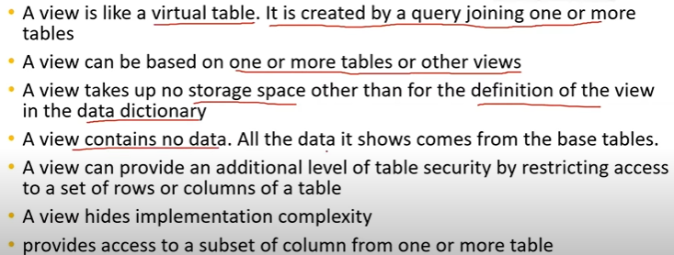

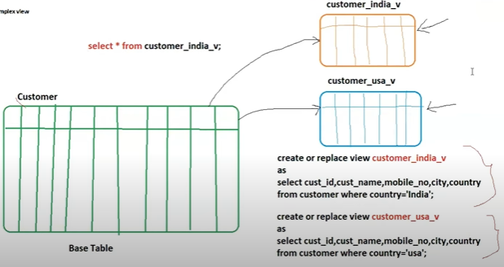

Oracle Queries

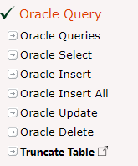

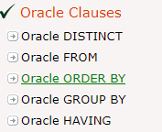

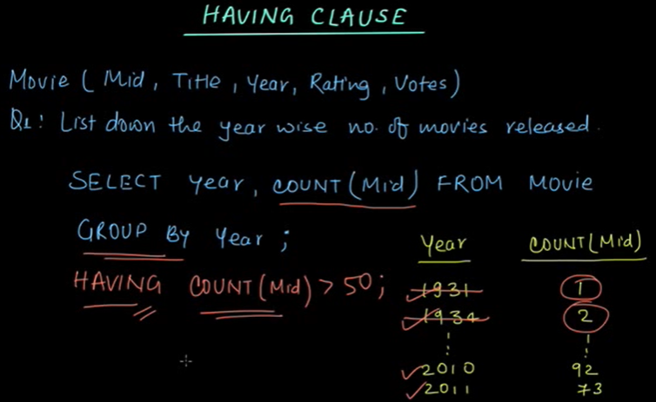

Having clause used to filter the data

Date and Timestamp:

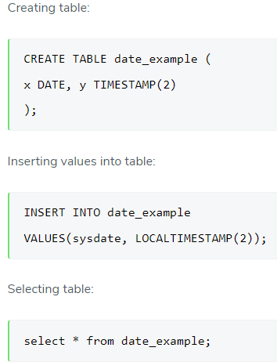

desc home; -- shows the column of the table

owner –varchr2

Rowid:

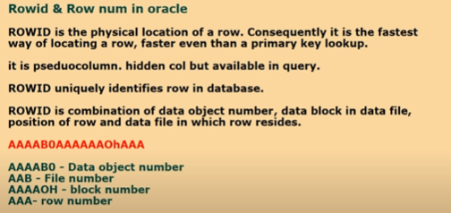

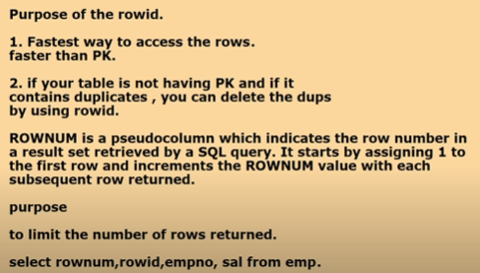

Eg:

Used to delete the data if the primary key is not available we can use rowed

Row num starts from 1 to 10 in order

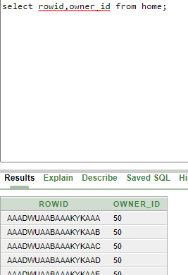

LOB: